Eight Discipline Report (8D Report)
To: Google SQE | 8D report No.:
From:：Chicony Power Technology | RMA claim No.: N/A
CC： | Chicony Power P/N: W030R18~023
CC： | Customer P/N: P18
Submit date: 2019/12 | Product description: Wall mount AC adapter
Receive date: 2019/12
Subject：The snap broken after Rel. test
D1.) 問題解決成員:Use Team Approach
主持者 (Team Leader)：Hamilton
內部成員 (Internal Team Members): RD: Hamilton /Alan
外部成員 (External Team Member): RUIDE : 胡执文/童雄輝
D2.)問題說明:Problem Description:
(Note: Use who, what, when, where, why, how, how many to specify the Customer’s problem.)
CPT has received the snap broken issue after Rel. test from DQA at DVT stage.
The failure pictures shown as below.
- P18 case has an abnormal sound after ball impact test (1pcs) and tumble test (1pcs).
→ Snap structure cracked.
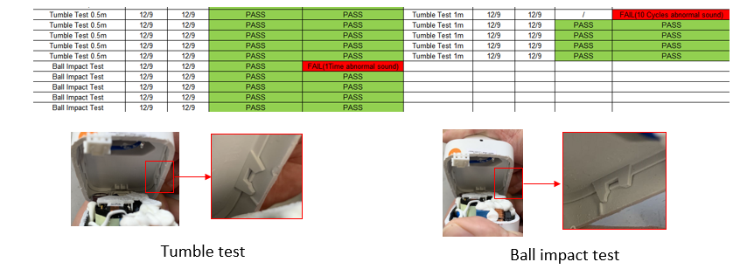
D3.)內部或客戶的暫時解決辦法及實施日期:Implement and Verify Containment Action:
(Note: Internal / external containment action effectiveness and date.)
Sorting 良品(晃動無異音) for客戶function測試用，並同步通知客戶找出真因提供改善對策
D4.)不良原因確認: Define and Verify Root Causes:
(Note: Identify and verify all suspect causes, which needs explain why the problem occurred.)
- Check cavity and ultrasonic welding parameters.
- Check failure cavity. Non regular distribution
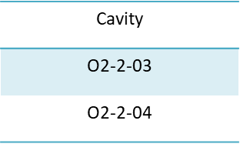

- Check molding parameters.
- Check ultrasonic welding parameters.
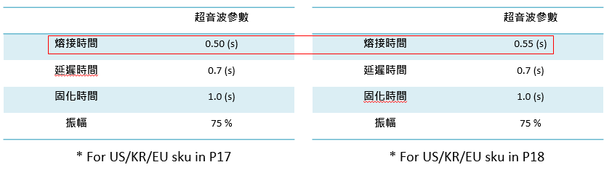
熔接時間較P17高，因P18為PCR材質比P17 PC材質需要較多的時間作熔接，故屬合理範圍
- Check MFI value.
- Check molding parameters.
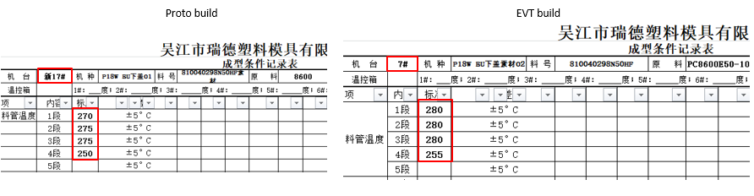
* Material mold temperature of Proto build is lower than EVT build, but the temperature is reasonable.
- To Validate MFI value. (Proto build and EVT build), MFI value is meet SPEC.
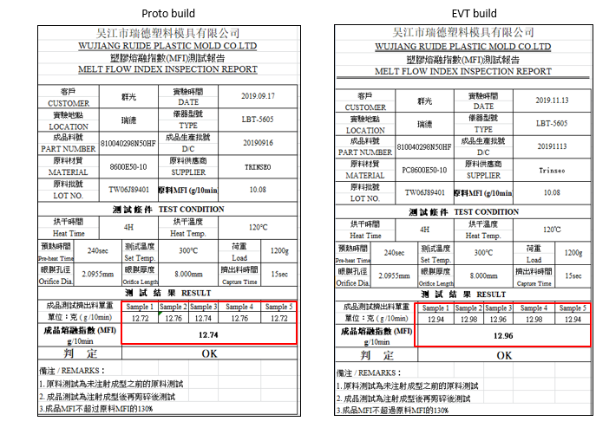

D5.)改善措施:Corrective Action Verification:
(Note: Be make sure the corrective actions is effective in process as well as able to fix the customer complaint problem)
- Add rib around the snap hole to increase the strength.
- Tooling modification for housing and AC cover will need 9 days
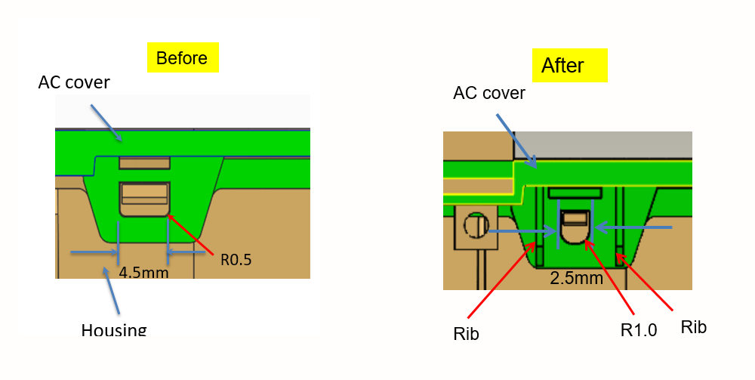
卡扣設計變更如下
  - Modify the snap from 4.5 to 2.5mm
  - Add R from 0.5 to 1.0mm
  - Add 0.6t Rib on each side
修模評估如下
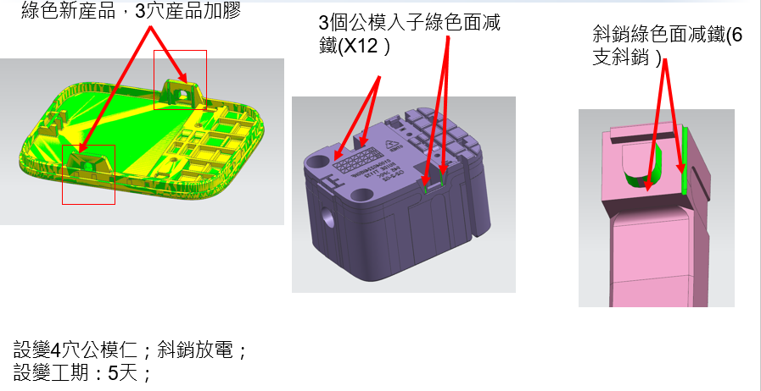
D6.)改善措施實施日期:Implement Permanent Corrective Actions:
(Note: Be provide the phase-in date or lot# of corrective actions implementation in process)
Implement Immediately and schedule listed as below
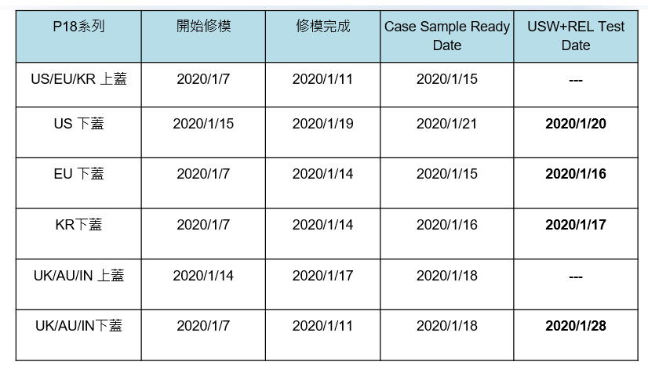
D7.)預防再發生措施:Prevent Recurrence:
(Note: Modified the management, operating systems, practices, and procedures to prevent recurrence for the problems as well as lessons learned cases.)
P18 Snap Molding Modification & Validation Result
- Samples: 10pcs Each SKU with improved snap design
- Tests: Tumble x 5pcs and Ball impact x 5pcs
- Result summary: see below table
AC plug | Tumble(5pcs) | Ball Impact(5pcs)
EU | All Pass | All Pass
KR | All Pass | All Pass
AU | All Pass | All Pass
IN | All Pass | All Pass
UK | All Pass | All Pass
US | All Pass | All Pass
- Disassemble the pass samples, and the snap are all intact without crack.

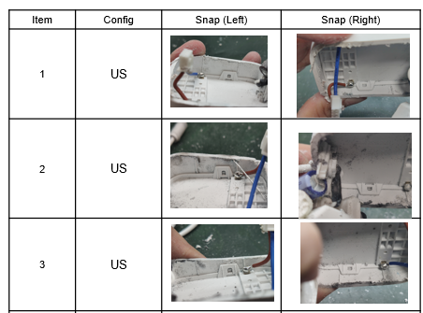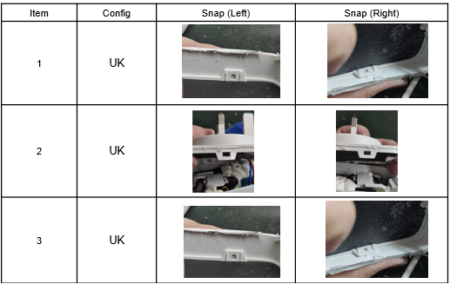
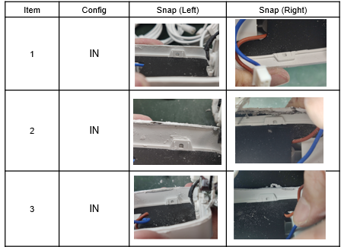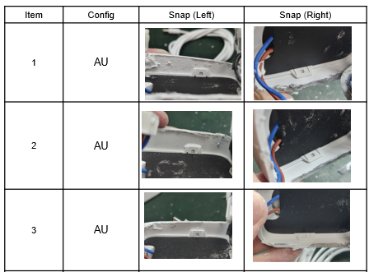
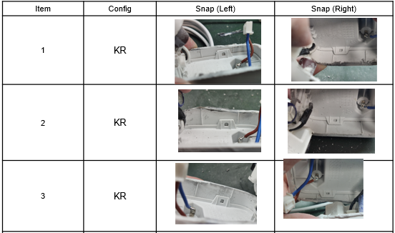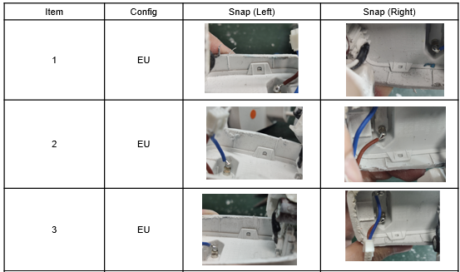

D8.)確認並感謝問題解決成員:Check and Congratulate the Team:
(Note: Recognize the collective efforts of the team.)
Thanks to you all！！！
CPT : Hamilton /Alan ; RUIDE : 胡执文/童雄輝

Signature
Team Leader:
Name – Title
Signature by Approver:
Name-Title

